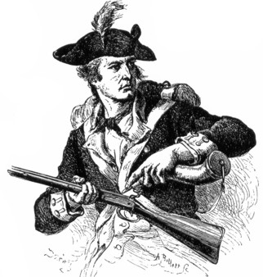 A Revolutionary War Re-enactment will take place at
[add location here] on [add date and time]
Take Notice!

You are hereby invited to take part and experience this living history event with the Regiment.

[insert specific driving directions to the event in this location from your school here or on the reverse side]

All “recruits” will receive a bounty of [ ] points by answering a few questions of the re-enactors.

[feel free to add or delete questions as they relate to your specific curriculum]

1. What are the regiment’s backpacks made of? ____________________________________________________

2. Ask one of the camp followers what they would prepare as a typical meal for the men. ___________________
_________________________________________________________________________________________

3. If this re-enactment portrays a specific battle, interview a soldier or officer and ask what the significance is of
this engagement. __________________________________________________________________________
________________________________________________________________________________________

4. What does a soldier do when he is asked to “prime and load”? _____________________________________

________________________________________________________________________________________

5. Ask the artillery what they are to do when ordered to “advance the round”? ___________________________
________________________________________________________________________________________

6. Ask the soldiers what weapon was the most reliable and “accurate” in the Revolutionary War. More soldiers
died from the proper use of this weapon than any other. ____________________________________________
_________________________________________________________________________________________

“Recruits” name: ___________________________________

